QMX Remote using ESP32
A little background…I began experimenting with using a couple inexpensive ESP32 modules when they appeared on Aliexpress for less than $5. I decided to get an ESP32-C3 and an ESP32-S3 based small (zero sized) modules. I also had a few ST7735 displays that were needing to be utilized, so I decided to build a small clock that would become an IoT device. That gave me some experience with the Arduino IDE for ESP32 and graphics on the small display. I thought it would be fun to figure out if I could talk to my QMX+ using the AUX serial port and the ESP32 serial port.
Hats off to Hans Summers for a great design on the QMX and his stellar documentation for the CAT command structures and the tools to monitor the CAT commands to the unit. That made this effort much easier.
The ESP32-S3 I used is a knock-off of the Waveshare ESP32-S3-Zero, and it has a limited number of IO pins due to the small package size. I decided to use 2 external switches and the rotary encoder switch for function selects, and a 1.8” 120x160 ST7735 display. The basic schematic is as shown:
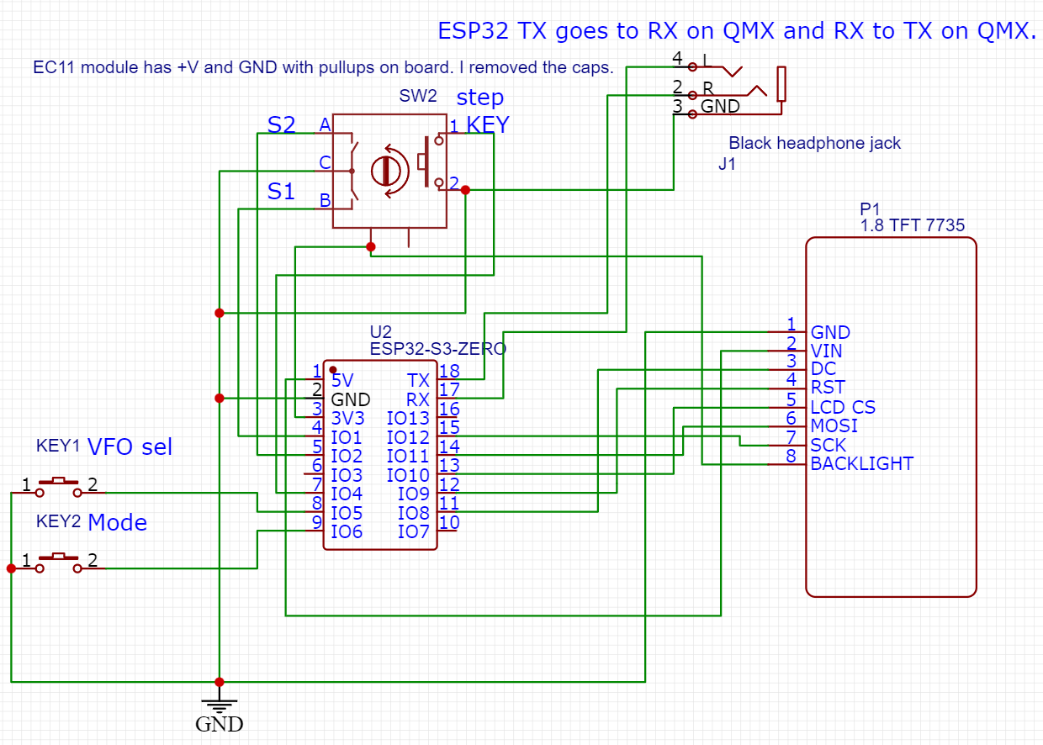
The backlight is always enabled in this scheme. IO3 and IO7 could be used to turn on and off the backlight, or to add another switch.
I did not put a battery in this set up, so it is powered from the USB-C cable that is plugged into the ESP32-S3 board. (It draws about 30mA with the display at full brightness).
I built the first pass on a breadboard and then put it all in a small 3D printed enclosure with point-to-point wiring. I didn’t attempt to do a PCB for this project.
This was my idea for the display:

VFOA TX SWR1.10 selected VFO and mode (If TX, then SWR is also shown)
14:00:00 Time
14.047.500 Freq
DIGI 10Hz Sxx mode step Smeter
T T T T T T xx:xx CW decode area and time if enabled

Here is a photo of the finished device connected to the QMX+ showing the unit connected to the QMX+ and operating.
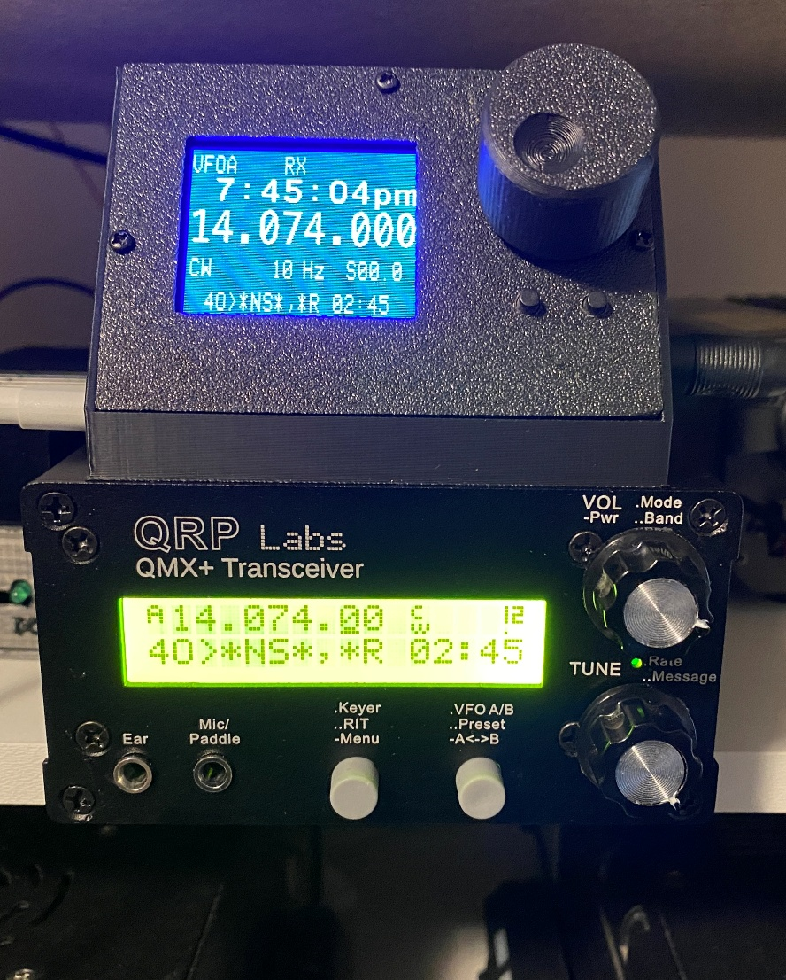

Operation summary
The remote display will connect to the QMX+ via the AUX serial port. The serial interface baud rate is set to 19200, with 8N1. This will need to be set up on the QMX using a USB serial port to control the menu system. Go to Main menu>Configuration>System config>GPS & Ser. Ports: Serial 1 on AUX: ENABLED, Serial 1 baud: 19200. (Note: I tried using higher baud settings, but that resulted in a lot of missed data, so settled on 19200).

There are 3 controls on the display:
The rotary knob with button on press, button A (left) and button B (right).
Functions:
Rotary knob will normally adjust the frequency depending on the selected step size. The step size is changed by a short press on the rotary knob. The step sizes are 10Hz, 100Hz, 1kHz, 10kHz.
The band can also be changed by a double click on the rotary knob (it must be ~300ms or less). The band will be shown in the lowest display area. The rotary knob can be turned to select the band desired, then the knob pressed to verify and the band will be changed to the selected. (This process needs some refinement since it required a change to the VFOA frequency to make the change, so previous VFOA settings are lost).
Button A is on the left and below the rotary control. It simply controls the selected VFOA or B.
Button B is on the right and below the rotary control. It controls the selected mode. The modes are cycled through: CW, DIGI, USB, LSB (same as QMX).

Display updates occur on a 1 second increment so there can be some visible lag on some data presented on the display. The updates from the rotary encoder are done during the main loop and are near real time.

Software and IDE build

The Arduino IDE 2.3.7 was used to build the code for this project. It will require the board manager esp-32 by Espressif Systems be installed, and the ST7735_LTSM library to be installed. Because of the limited pins on the ESP32-S3-Zero package, a modification to the following file needs to be made to provide an SPI interface on the IO pins used. This is to change from the defaults. Here is the note in the code:
// NOTE: To map the SPI to available pins, a change to the file in this location is necessary:
// C:\Users\xxxxx\AppData\Local\Arduino15\packages\esp32\hardware\esp32\3.x.x\variants\waveshare_esp32_s3_zero\pins_arduino.h:
// Mapping based on the ESP32S3 data sheet - alternate for SPI2
// static const uint8_t SS = 10; // FSPICS0
// static const uint8_t MOSI = 11; // FSPID
// static const uint8_t MISO = 13; // FSPIQ
// static const uint8_t SCK = 12; // FSPICLK
This gives the display a fast update capability and works well.

The chosen frequencies for the band-switch are as follows:
160M 1.9MHz
80M 3.6MHz
60M 5.3585MHz
40M 7.1MHz
30M 10.125MHz
20M 14.150MHz
17M 18.110MHz
15M 21.2MHz
12M 24.930MHz
10M 28.3MHz
6M 50.1MHz
These can be changed in the code if needed. As built, they are constants.

Caveats and improvements

The code for this was built without the use of any extensive buffer management, and with easily accessible libraries within the Arduino IDE. That said, there is a slight lag time during the 1 second display refresh on reading the rotary encoder, so it may feel like it misses once in a while.

Band switching using the double-click on the encoder is not fully consistent, but it quite functional. Just takes some getting used to. A third control switch could be added to make this easier, but I had already built the enclosure by the time I decided to add band switching.

The ESP32-S3 has built in Wifi, so it would be possible to create a server page that could also show the same information as the display, but that is beyond what I intended for this effort. Also, the S3 does not support a Bluetooth SPP stack, so it can’t be fully wireless to the QMX with simple Bluetooth serial modules.

